1、解包游戏包

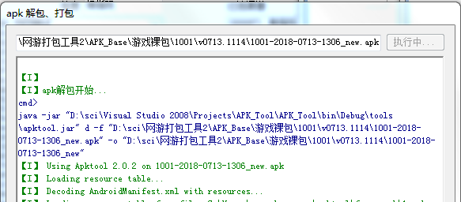

2、修改所有Landroid/support/为Landroid/support2/

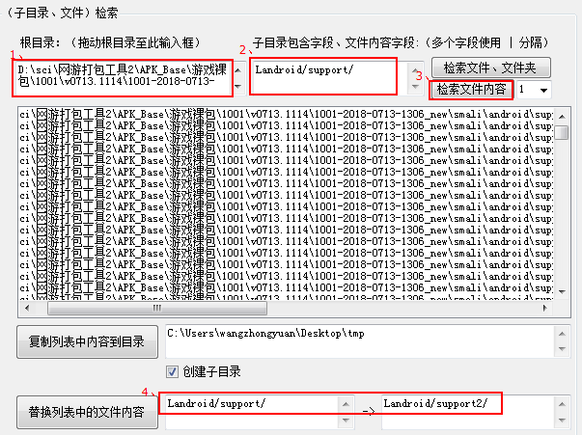

https://git.oschina.net/scimence/fileExtractionTool/raw/master/files/FileExtractionTool.exe

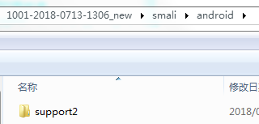

3、生成新的裸包

